11 April 2007

ParOS plc

(“ParOS” or the “Company”)

Hydrogen Fuel Cell Conversion for Greek Buses
ParOS plc, the AIM listed company, today announced its involvement in the delivery of a conventional diesel powered Minibus to the Research and Development Teams for conversion into the first Greek Hydrogen Fuel Cell Powered Minibus. ParOS Technology EPE, a Greek Subsidiary of ParOS plc, is part of the Development team. The delivery took place on 28 March at the Ministry of Transportation in Athens. The Minister of Transportation, Mr. M. Liapis, delivered the Minibus personally and stated:

‘The Ministry of Transportation and Communication’s first priority is the improvement of citizens’ quality of life. I strongly support this attempt to reduce emissions in the city of Athens by introducing the first Greek Hydrogen Minibus. Greece is one of the leading countries in Europe in research and development of hydrogen technology which is regarded to be the fuel of the future. We would like to give a boost to such innovative technology developed in our country. With great pleasure I hand over today this diesel powered Minibus to the Research and Development Teams. I am really positive and hope that we are not far from the day where every bus in Athens will emit only water from its exhaust pipe’.

The Research Team from Greek Universities, Research Institutes and Greek Research companies includes NTUA (National Technical University of Athens), Demokritos Institute, CRES (Centre of Renewable Energy Sources), Air Liquide S.A., Helbio S.A., Pros S.A. and Diadikasia S.A.

The Development Team from Greece includes, Tropical S.A. Advent S.A., ParOS Technology EPE, EAS S.A. and Elety which will cooperate to modify the body and the chassis of the Minibus and develop the “Roof Rack” for the Hydrogen related systems which include the fuel cells, the power inverters, the electronics and control compartment and the inverter technology air conditioning unit.
Dimitrios Alamaniotis, CEO of ParOS Technology EPE, said: ‘ParOS Technology EPE was formed to focus on the reduction of waste and environmental emissions. This Minibus project is expected to enhance the Company’s ability to generate sales’.

For Enquiries:

ParOS
Patrick McHugh Tel: 020 3008 8223

John East & Partners Limited (Nominated Adviser)
Simon Clements Tel: 020 7628 2200

Holborn Public Relations

David Bick/Mike Feltham Tel: 020 7929 5599

Background Information on ParOS

ParOS advanced optimisation and control solution technologies have been developed by a team, led by Chief Technology Officer, Professor Pistikopoulos, at Imperial College’s Centre for Process Systems Engineering, over the last 15 years. ParOS became a spin-out company from Imperial College in January 2002 providing energy saving advanced optimisation and control solutions to industry. In March 2006 ParOS plc was admitted to trading on AIM with a view to commercialising its existing technologies and to utilising its intellectual property pipeline agreement with Imperial College.

Advanced control, referred to as Model Predictive Control (“MPC”), is achieved by repeatedly solving optimisation problems online to determine the best control action, given the sensor measurements at any given time and a desired target value for these measurements. Until now providing hardware and software applications to support MPC has been expensive and time consuming. ParOS technology overcomes these obstacles using parametric optimisation techniques to determine MPC solutions offline that run online with low cost process controllers. ParOS’ solutions are currently installed in the Automotive (Active Valve Train) and the Process (Air Separation Systems) Industries.

ParOS is developing control solutions for the energy systems of the future including hydrogen storage in solid metal hydrides and portable and standby hydrogen based fuel cells for use in power generation and transportation.

For further information please visit http://www.parostech.com

Delivery of a Diesel Minibus to the Research and Development Teams for conversion to Hydrogen Fuel Cell Power
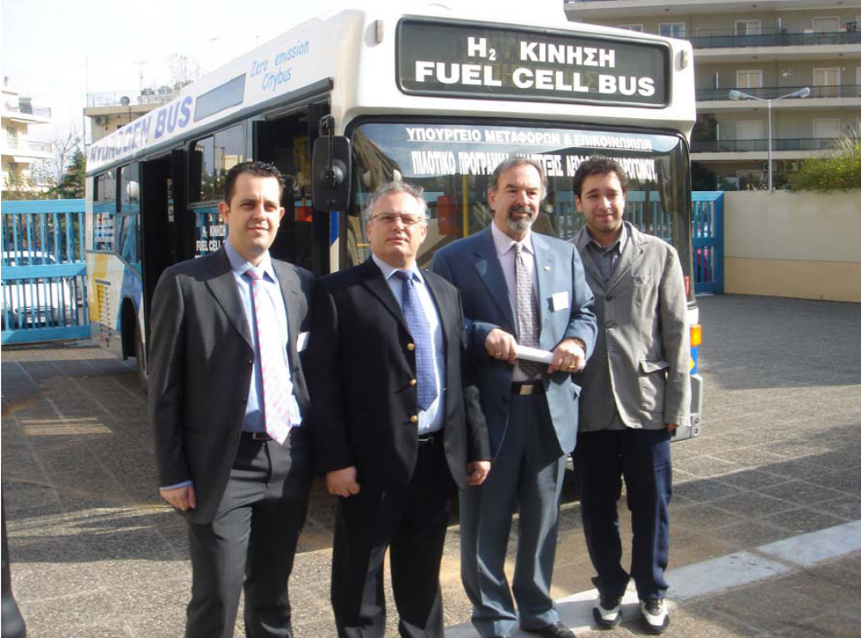
Mr G. Lagios, CEO and President of Tropical SA and Mr D. Alamaniotis, CEO of ParOS Technology EPE, second and third from left respectively, in front of the Minibus.

